1553 NW Ballard Way, Seattle, WA 98107 | La Marzocco  Marco  Mazzer | Phone: 206.706.9104  Fax: 206.706.9106  Web: www.lamarzoccousa.com

La Marzocco Technical Bulletin #89A – March 2014
New Diffuser Screen

Dear La Marzocco family members,

We have created a new diffuser screen F.3.040 that will be used in all production, replacing L107.

The new screen is reinforced and now has also our Logo printed on it.

We introduced this improvement in production on all our machine models from these S/N:

Linea PB – PB00354
Strada – ST001250
GB5/FB80 – GB010110
Linea/FB70 – L040726
GS3 – GS003745

DIFFUSER SCREEN (F.3.040)
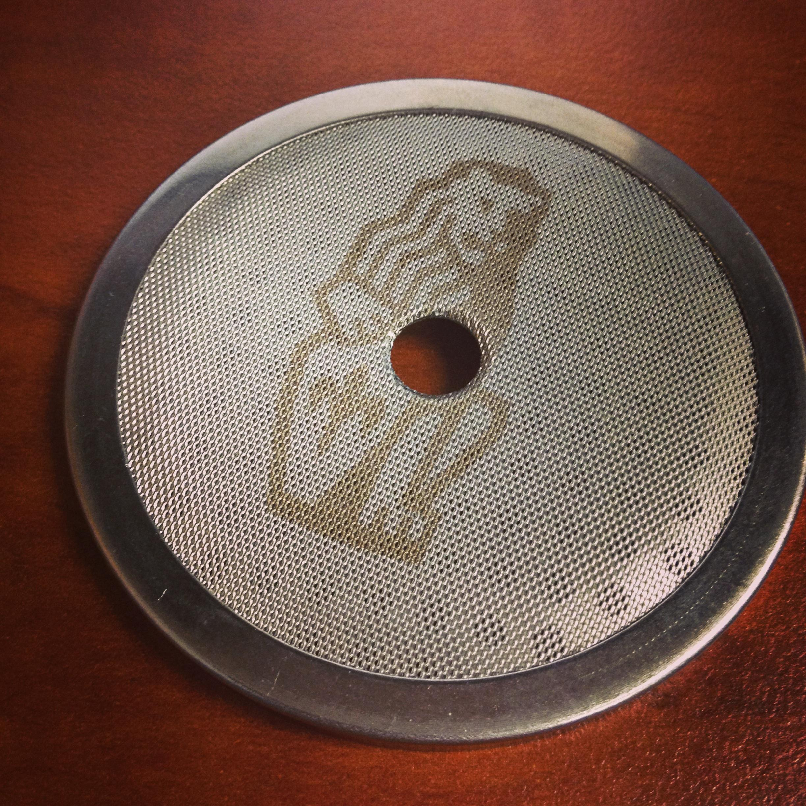

The new screen F.3.040 is available and the screen L107 will remain available.

Best regards,
After Sales Department
Larry Eister Larry@lamarzoccousa.com
Scott Guglielmino Scott@lamarzoccousa.com
Support Team Support@lamarzoccousa.com

